SPANISH Faculty Member
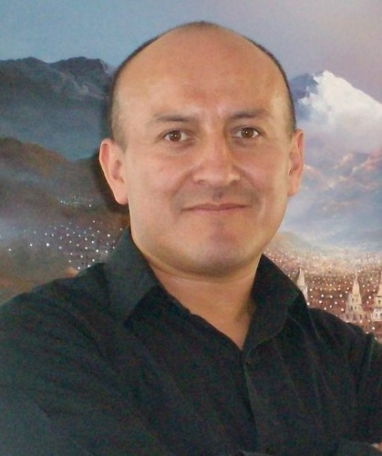
Luis Contreras

Mr. Contreras has over 20 years of experience teaching Spanish to children and adults who speak English as their first language. Born in Ecuador, he worked in schools catering to foreign students and taught Spanish at elementary and high school levels, designing the curriculum for all his classes. He also spent many years as Advisor and Academic Coordinator at several institutions in Ecuador, where he designed the Spanish language curriculum for academic-credit courses for college students from American universities completing an internship and cultural experience to further enhance their Spanish language skills. In Rhode Island, he taught Spanish at the Trinity Academy for the Performing Arts, the Rhode Island Nurses Institute Middle College Charter High School, at the Mount Pleasant and South Providence Community Library and offers private lessons as well.
Luis has great interest in the arts. He was an actor in “La Matraca” Theater and a dancer at Ballet Andino Humanizarte. He also served as a tourist guide/interpreter for excursions, field trips and visits to Ecuadorian places of interest such as museums, churches, mountains, describing the culture and history to European and American tourists. Always interested in serving the community, he learned Sign Language to communicate with hard-of-hearing friends and worked with various indigenous communities from Ecuador. He is founder and Vice President of Programs of the “Ecuador Cultural Alliance” a nonprofit organization that promotes education and culture in rural schools serving primarily indigenous, low income families in the province of Imbabura, Ecuador.
He has a Bachelor of Science in Education, concentration Spanish Language and Spanish Literature from Universidad Central del Ecuador. He also holds Certification No. 66510 from the RI Department of Education as World Language Teacher, Grades PK -12 –Spanish. In his free time, he helps raise funds for Ecuador Cultural Alliance, DJs for family events, and plays tennis.

