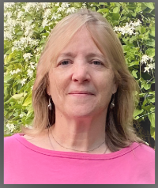

Armelle Les Carbeau

Armelle is a Professor of French who was born and raised in Versailles.
After travelling through Australia and South-East Asia for over 18 months, she received a Master in English Civilization and Literature from the University Paris 7 Jussieu. It is during the course of writing her master’s thesis that she came to America for one year, which has now turned into nearly 30. She has since been teaching languages (including Latin) at all levels, from 7th graders to College students and adults, as well as, recently, grade schoolers.

Her father’s family being from the Bretagne region of France, Armelle, like all Britons, has a strong sense of cultural heritage, mixed with appreciation for all other cultures due to the fact that her mother was born and raised in Morocco, before settling in the ancestral family region of the Loire Valley in France.

Armelle loves reading, cooking, history, travelling, sharing with other cultures and learning about people in general. She has a particularly strong love of chocolate.
She now spends her time between her two homes in Vermont and Rhode Island with her husband and 2 young cats. Armelle frequently visits family in France.

Armelle has been an instructor of French at the Alliance Fran$ç$aise of Providence since 2018. She often contributes French culinary delights to the Alliance events.

