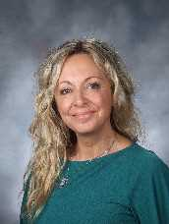
Laure Bessiere Hallworth
Laure was born and raised in Toulouse, France and grew up with Spanish and French as her native languages (her dad being from L’Aveyron and her mom being from Andalucia, Spain) . She received a Bachelor in Spanish studies with a concentration in cultura y literatura Castellana from L’université du Mirail.
She worked at La Cinémathèque de Toulouse as an intern as well as for the city of Toulouse as a culture and history tour guide and maintained a private own business in language tutoring.
Her passion for cultural diversity and love of traveling brought her to the US in 1999 where she started teaching Spanish and French in different middle schools throughout the state Rhode Island for 15 years before accepting a fulltime position as a World Language teacher at Bishop Feehan High school in Massachusetts where she teaches all levels in Spanish and French.
Laure has been a friend and teacher ( all levels and conversational) here at L’ Alliance through the years and has been in charge of children and teens’ classes as well as summer camps at different times.
She continues her private owned tutoring business (all levels) with students at Brown University, Providence College and different Schools in RI and MA.
Laure loves traveling, hiking (she has a passion for outdoors) and cooking: she has held cooking workshops at Bancroft high school, Alliance Française de Providence and is in charge of a cooking club at Bishop Feehan HS.
She lives in Lincoln, RI with her daughter Abbi, her son Nate and their dog Oakley .

