SPANISH Faculty Member
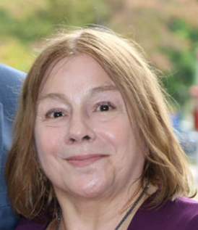
Gina Canepa
I was born in Santiago, Chile in a well-read family and as lover of literature, visual arts and music. My father was a historian of Chilean theatre. My mother majored in visual Arts. As a teenager, I was a member of Jeunesses Musicales Internationale, Belgium and president of the Chilean section and an active member of the Wagnerian Circle of Chile.
From 1968 to 1972, I studied musicology at the University of Chile with a minor in philosophy. I wrote articles on musical criticism in Eva magazine, a publication dedicated to women's issues. I was active in the movement that supported the university reform of 1968, and then worked for the 1970 presidential election campaign of Dr. Salvador Allende. I graduated in 1972 with a degree in musicology and a minor in philosophy. From 1971 to 1973, I was a teacher assistant to Professor Augusta von Godin, an instructor of history and cultural studies. In 1974, I had to leave my country because of the military coup d’ ètat of Augusto Pinochet. I took refuge in the former West Germany.
Nothing was easy in West Germany in terms of adaptation. At that juncture, I started studying Latin-American Studies, with two minors, musicology and philosophy, at the Freie Universität Berlin. I focused on Latin American Literature and Culture. In 1981, I worked in the Spanish department of the University of Odense, Denmark as a visiting professor. I taught at the Freie Universität Berlin from 1986 to 1990. Here, I completed my Ph.D. in Latin-American Studies. I was an active member of the European Association of Literature and Society of Latin America. I was also a member of the research team of Prof. Alejandro Losada until 1985 at the Freie Universität Berlin to formulate a social history of Latin-American literature. The project was discontinued after Prof. Losada died in a tragic accident. My son Mauro was born in Germany.
In 1991, I taught at the University of Bergen, Norway as a visiting professor. In 1992, I moved to Wellesley, MA to take up a vicariate at Wellesley College, MA as a visiting assisting professor. After this assignment, I taught one semester at Providence College, RI as a visiting professor, and for six years at Connecticut College as a Senior lecturer. From 1999 until 2015, I instructed Latin American Literature as a Senior lecturer at Providence College.
I retired in 2016, but I am still active in the New England Council of Latin American Studies since 2005. I was elected ex-officio of the organization in 2012. I also teach different levels of Spanish at the Alliance Française of Providence since 2016. I continue to research and publish in the field of cultural studies, women's studies and Latin-American literature and cinema. I live in Rhode Island with my American husband and my cat Eloise. My son Mauro lives in Brookline, MA with his wife Denise.

